Safety Briefing

BISRA GaddinAbtGarnish 2026.2

Welcome to the 20th BISRA GaddinAbtGarnish Swim around Garnish Island.
We are likely to have almost 350 swimmers, many have returned and for many this is the first time entering an Open Water Swim.

Following a number of close shaves in the last 2 years we are introducing an additional safety measure: A colour coded swim cap supplied by us at registration MUST be worn.

No Hat – No Swim!
5k – Red, 3k – Yellow, 2k – Orange, 1k – Green

- The GADD is not meant to be a race.
- There will be no timing system in operation – use your own watch as a back-up.
- Mind the shallow passages at all three corners and in front of the slipway on Garnish Island.
- 5k swimmers will start first, followed by 3k swimmers next and 1k swimmers last.
- We will ask you to line up on the slipway before the start by wave numbers.
- We need to count you in. To facilitate this line up in rows of 5 across the slipway.
- There will be approx. 2 mins interval between each wave of 30 swimmers.
- If the sun is setting, regular sighting is important on the way back to the slipway.

High Tide is forecast for 19:27 at approx. 3.40 m and the Sunset is predicted for 21:02.

Weather permitting - the course will go around the group of islands at the south side of Garnish. The narrow passage at corner 3 is no longer part of the route. Instead, an orange buoy will guide you further east.

Water levels will rise throughout the swim.

THE COURSE IS AS FOLLOWS:
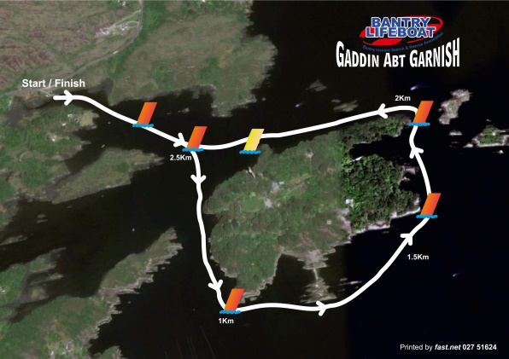
Swim towards the 2nd orange buoy opposite Garnish Island pier leaving that buoy on your right shoulder, then veer right towards corner 1. From then on keep turning left. An orange buoy marks corner 1 swim towards a group of small islands on the south of Garnish – round them on the outside. Another orange buoy marks corner 2. The 5th orange buoy is placed at the north east corner steering you away from the narrow passage we used to guide you through in the past. Turn left and head towards the yellow buoy off the slipway on Garnish Island.

5k swimmers will swim around the island twice, 3k swimmers once. In order to reach the full distance, keep the yellow buoy off the slipway on Garnish on your left shoulder before starting lap 2. On the home journey, again the orange buoy off Garnish has to be rounded passing it on your right shoulder.

There will be a kayaker off Garnish Pier who will turn all swimmers towards home if they reach that point later than 60 mins (leaving 45 mins to finish 2.5k) after the start of the 5k swimmers. After that time, we consider it to be too late to start the final lap.

All swimmers who lap the island return towards the slipway at Ellen’s Rock keeping the orange marker buoy on their right shoulder. We have placed a further orange buoy half way towards the slipway at Ellen’s Rock. If the sun is setting sighting is very important. Stay slightly to the right of the bungalow.

Give the steward on the slipway your swim number to mark you as ‘home’.

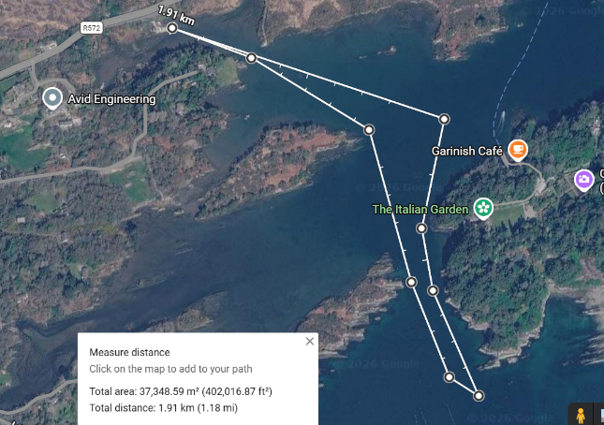
2k swimmers head past the first 2 orange buoys and veer right towards corner 1. There they round the orange buoy, keeping it on their right shoulder and swim away from the swim course towards the mainland for approx. 10 m. Then turn back, passing 2 headlands on their left until they reach the original 2 orange buoys and head home.

1k swimmers pass the 1st orange buoy heading towards the 2nd orange buoy, round it with the buoy on your right shoulder and return to the slipway.

If Water Temperature is not as warm as you would like it to be and you’re in doubt cut your swim short or decide to wear the wetsuit.
Hypothermia is a serious matter – don’t risk it.
Strict Instruction – Don’t shed your wetsuit today if you haven’t swum regularly without it this summer.

If you for some reason don’t feel 100% today the smart thing to do is not to enter the swim or to turn back as soon as you realise today is not your day. Should you feel uncomfortable turn on your back and relax for a bit. For assistance raise an arm with a closed fist and a kayaker or rib will come to your assistance pronto. There will be ribs stationed at each corner of the island and kayakers will patrol between the corners, so you won’t be very far from help at any stage.

All instructions given to you by Water Safety Officers have to be followed without argument. Failure to do so will result in debarment from future Open Water Swims organised in the Munster Region.

We acknowledge the generous support of Cremin Coaches, Kealkill, Co.Cork.

Water Safety is provided by Bantry Inshore Search & Rescue Association (BISRA), Coast Guard Castletownbere, the Bantry Harbour Master, Phoenix Kayak Club & West Cork Kayakers. We have a doctor and Bantry Red Cross Ambulance standing by. Road Safety is in the hands of an Garda Siochana.

We would like to thank all our support and safety crews for their assistance in making BISRA GaddinAbtGarnish one of the most enjoyable and safe swims in Munster.
Ossi Schmidt & Colm Walsh
Event Organisers BISRA GaddinAbtGarnish 2026.2

